Paper Template for 13th International Conference on Fracture

FirstName LastName^{1,*}, Second Author¹, Third Author²

¹ Department of AABB, CCDD University, City Post Code, Country
² Faculty of EEFF, Institute of GGHH, City Post Code, Country
* Corresponding author: email@address.aa.b.cc

Abstract Enter your abstract here in 11 pt. font Times New Roman with NO more than 200 words.

Keywords Keyword 1, Keyword 2, Less than 5 keywords

1. Introduction

This is a template to prepare the full paper manuscript for the 13th International Conference on Fracture, which will be held at Beijing, China, June 16–21, 2013.

The total number of pages should be less than 10 including figures, tables and references. The full text should be written in English. Use correct, clear, reader-friendly English and write concisely.

2. Typesetting

Use Microsoft Word. Upper and lower case letters are to be used throughout. Single line spacing is to be observed throughout and all paragraphs full justified (left and right). All textual elements should begin flush left, with no paragraph indents. One return should be placed after every element such as title, headings, paragraph, and figure captions. Automatic page numbering or footnoting features can be used. Use Times New Roman font thorough the whole text. Be sure not to use two-byte fonts, which are typical of Japanese, Chinese, and Korean language kits. Two-byte fonts are often unintentionally typed as spaces between words, figures, tables, and symbols.

2.1. Page Set

(1) Use an A4 size format (297 mm×210 mm in height and width).
(2) The margins are Top: 25 mm, Bottom: 25 mm, Left: 20 mm, and Right: 20 mm.

2.2. Title and author information

(1) Use 14 pt. Bold Times New Roman for the title.
(2) The title should be flush-centered.
(3) The names should be written with 14 pt. Bold Times New Roman.
(4) The presenting author must be underlined.
(5) Do not abbreviate the first and last names. Only the middle names can be written with initials.
(6) Attach a superscript natural number (1, 2, 3, …) at the end of each author's name to identify the affiliation. The same superscript must be used for the same affiliation.
(7) Use 10 pt. Times New Roman for the affiliations.
(8) The author names and affiliations should be flush-centered.
(9) Write a superscript natural number (1, 2, 3, …) before each affiliation.
(10) The affiliation should contain (i) the name of university, company, organization or institute and country and (ii) the e-mail address of, only, the corresponding author.

2.3. Main text

(1) Headings should be numbered.
(2) Write the major headings with 14 pt. Bold Times New Roman.
(3) Write the sub-headings with 12 pt. Bold Times New Roman.
(4) Write the sub- sub-headings with 12 pt. Italic Times New Roman.
(5) Do NOT use more than three heading levels.
(6) The body should be written with 12 pt. Times New Roman with single line spacing.
(7) Greek symbols are acceptable to denote several physical quantities. Use only standard symbols and abbreviations in text and figure/table illustrations.
(8) Units should be expressed in the International System of Measurement (SI) or metric system. Where desirable, conversion into a duplicate set of units may be shown in parentheses in text or illustrations.

2.3.1. Equations

Equations placed on a separate line should be centered and numbered consecutively from one without reference to heading level. In Equations, use 12 pt. Times New Roman and Symbol. Use 7 pt. fonts for subscripts and superscripts as follows:
,
.

Any numbered equations must be cited in text as, i.e., (Eq. 1), see Eq. (2), etc.

2.3.2. Figures and tables

Figures and tables are to be arranged in the text as they are to appear in the published proceedings. For this reason, please keep the blank space around figures and tables to a minimum as this will ensure that the content of figures and tables can be reproduced as large as possible. Use large enough lettering so that the smallest elements (i.e. superscript or subscript characters) will be readable when the figure is reduced. The resolution of figures should be at least 300 dpi.

Figures and tables should be centered. Figure captions (Figure 1. Schematic diagram ... ) will be placed bellow the figure, whereas table captions (Table 1. Coefficients ... ) above the table, with 11 pt. Times New Roman. Examples of a Table and a Figure are as follows:

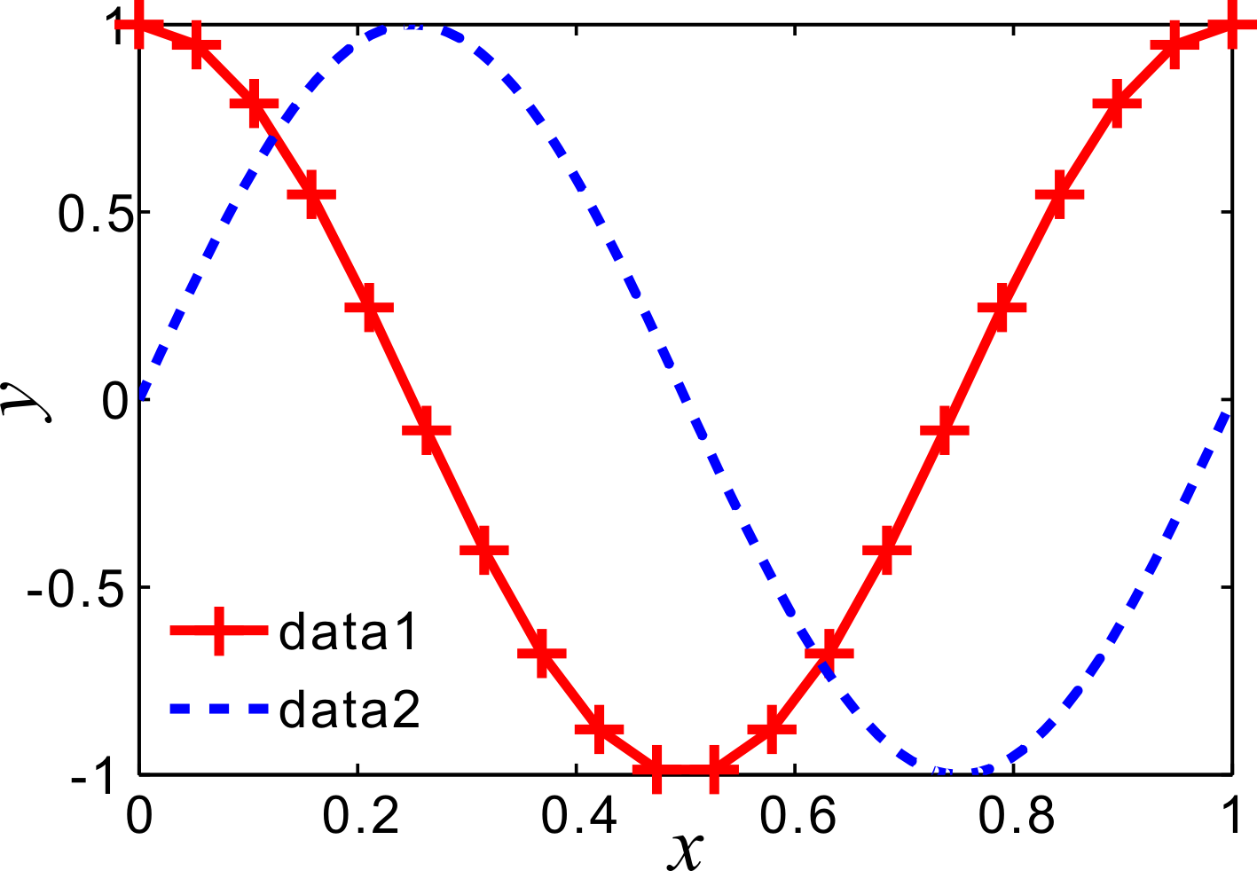
Figure 1. Example of figures
Table 1. Example of tables
ICF11 | Turin, Italy | 2005
ICF12 | Ottawa, Canada | 2009
ICF13 | Beijing, China | 2013

Figures and tables must be cited in text as, i.e., (Table 1), in Fig. 1, etc.

2.4. References

References should be indicated in the text by consecutive numbers in brackets, i.e. [1], [2, 3], [4–6]. Full references should be cited in a numbered list at the end of the manuscript. References should contain the names of all authors of any one paper together with their initials, the article title, the title of the journal (abbreviated if possible in accordance with the World list of Scientific Periodicals), volume number, page numbers, and year, as illustrated below. References to books should contain the publisher’s name and location.

Journal article:
[1] H. Uchikawa, S. Hanehara, T. Shirasaka, D. Sawaki, Effect of water curing. Cem Concr Res, 22 (1992) 115–120.

Book:
[2] H.F.W. Taylor, Cement Chemistry, Academic Press, New York, 1990.

Article in Edited Book:
[3] D.F. Hewlett, P.D. Jones, The effect of superplasticizers on concrete materials, in: G. Fontinou, P.D. Jones (Eds.), Chemicals Admixture, Academic press, New York, 1981, pp. 135–155.

3. Submission of the paper manuscript

Full paper should be submitted electronically via the Paper On-Line Submission function on the conference website (http://www.icf13.org) no later than January 10, 2013.

Acknowledgement of receipt of the submission will be sent to the author’s e-mail address. It is the author’s responsibility to submit a correct manuscript; any errors in spelling, grammar, or scientific content will be reproduced as typed by the author.

Please avoid sending the paper by e-mail and do it only if necessary. If you have any questions, send an e-mail to ICF13am@cstam.org.cn.

Acknowledgements
Acknowledgements belong here.

References
[1] H. Uchikawa, S. Hanehara, T. Shirasaka, D. Sawaki, Effect of water curing. Cem Concr Res, 22 (1992) 115–120.
[2] H.F.W. Taylor, Cement Chemistry, Academic Press, New York, 1990.
[3] D.F. Hewlett, P.D. Jones, The effect of superplasticizers on concrete materials, in: G. Fontinou, P.D. Jones (Eds.), Chemicals Admixture, Academic press, New York, 1981, pp. 135–155.

