ICF14 Executive Chair’s Progress Report presented to
The Founder President, President, Executive & Council of the International Congress on Fracture
ICF: The World Academy of Structural Integrity
At the Thirteenth International Conference on Fracture (ICF13)
Beijing, China, June 16-21 2013
Professor E.E. Gdoutos
ICF14 Executive Chair’s Progress Report
(1) This is to provide a progress report of the Executive Chair of the Fourteenth International Conference on Fracture (ICF14) on ICF14 for the ICF Executive Committee Meeting on June 17 2013 and for the ICF Council Meeting on June 18 2013 at the Olympic Conference Centre, Beijing, China at the Thirteenth International Conference on Fracture (ICF13).
(2) The Fourteenth International Conference on Fracture (ICF14) will take place at the Rodos Palace Hotel and Conference Center (RPHCC), Rhodes, Greece, June 18-23, 2017. It is a Pan-Europe, Greek-Anglo-German consortium with Emmanuel Gdoutos as Executive Chairman, Maria Konsta-Gdoutos and James Marrow as Technical Programme Chairs, Dietmar Klingbeil as Industrial Programme Chair and David Taplin as International Steering Committee Chair.
(3) The ICF14 website was launched with information about the conference. ICF14 website. Links include: Welcome by the ICF14 Executive Chair Emmanuel Gdoutos, Welcome by the ICF-WASI CEO David Taplin, CV of Emmanuel Gdoutos, Scientific Program, Local Organizing Committee, Scientific Committee, Important Dates, Tentative Program, General Information, Transportation, Publications, MoU ICF14, ICF Statutes, ICF-WASI, ICF-WASI Chapter in Greece, ICF-WASI Awards, Nominations Committee Report, Awards Committee Report, ICF14 Bid Document.
(4) ICF14 will take place at the premises of Rodos Palace hotel and Conference Center (RPHCC), a five star hotel overlooking the Aegean sea. The hotel has world standard facilities to accommodate a conference of more than 2,000 participants. The hotel has a capacity of 850 rooms of which 500 will be available for the conference. Other smaller hotels of various categories are in proximity of less than a kilometer from RPHCC to accommodate conference participants.
(5) Transportation to Rhodes is convenient with many direct international flights from European cities. Direct flights to Rhodes operate from Athens and Thessaloniki. Rhodes can be reached from Athens by ferry.
(6) A site visit took place in March 2013 to Rhodes by Emmanuel Gdoutos and David Taplin. A very full site tour and presentation by the staff of Rodos Palace Hotel (RPHCC) was made. The RPHCC facilities were comprehensively inspected and found to be in all respects excellent, world-class and suitable for ICF14 involving up to 2000 delegates including a Plenary Lecture Theatre and a spectacular Banquetting Hall as well as a full range of variable break-out meeting rooms.
(7) A flyer of ICF14 containing information about ICF14 is ready and will be distributed to the ICF13 participants.
(8) During ICF14 a series of special symposia in cutting-edge technologies honoring renowned scientists will be organized.
(9) ICF14 will be a catalyst for structural metamorphosis of ICF into “The World Academy of Structural Integrity.”
Respectfully submitted.
Emmanuel Gdoutos
ICF14 Executive Chair
April 12, 2013
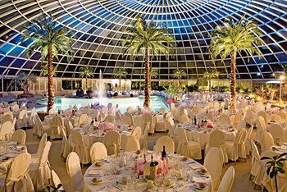
Banquetting Hall, Rodos Palace Hotel
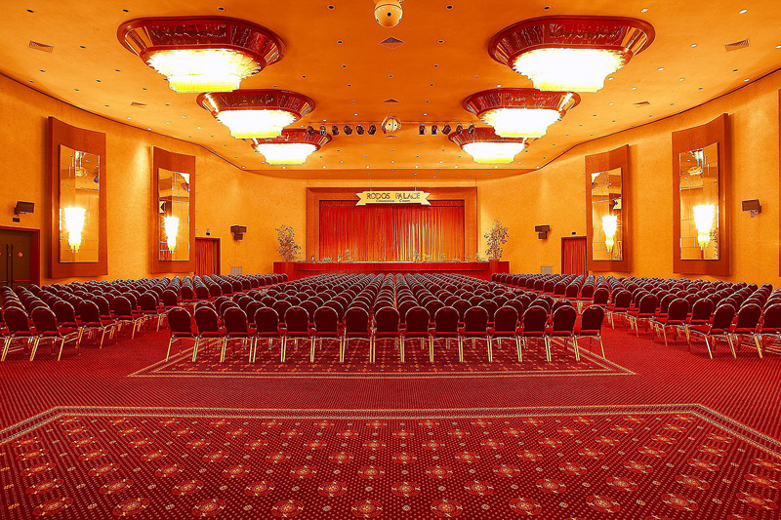
Conference Hall, Rodos Palace Hotel
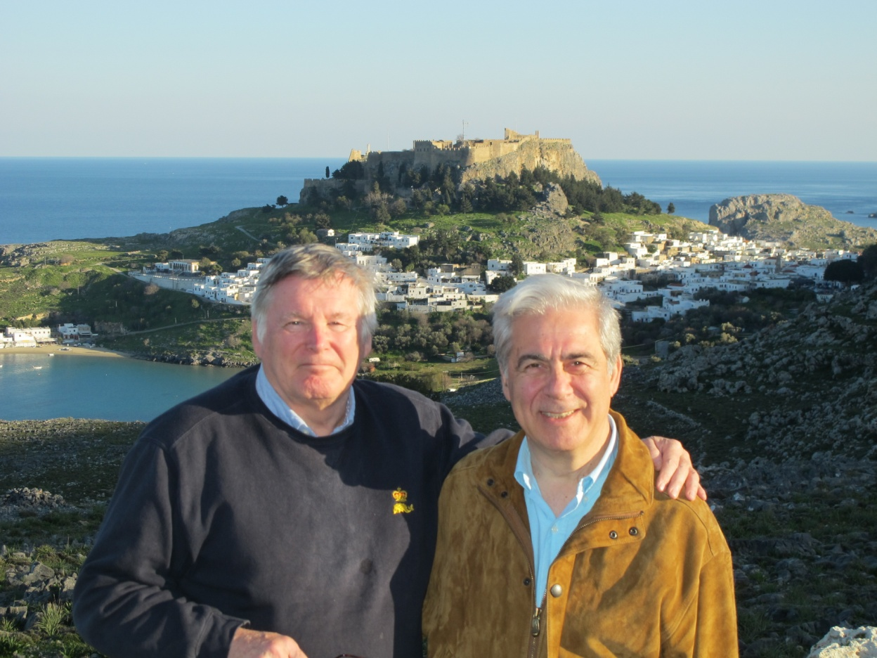
D Taplin and E. Gdoutos in the ancient city of Lindos, March 1, 2013.

